Statement of Work

Grainger PLC
GDPR Anonymisation

Version 1.0
April 5, 2024

Contents
1 Statement of Work 3
1.1 Overview 3
1.2 Objectives 3
1.3 Delivery Approach 4
1.4 Responsibilities 4
1.5 Availability 5
1.6 References 6
2 Project Risks, Assumptions & Exclusions 7
2.1 Risks 7
2.2 Assumptions 7
2.3 Exclusions 8
3 Cost and Timelines 9
4 Acceptance 11

Statement of Work

Overview
Grainger plc has recently had some audit findings from PwC highlighting the potential non-compliance with GDPR regulations relating to personally identifiable information (PII) for individuals who were either unsuccessful prospective tenants or are no longer active tenants. This data is held in the Grainger plc Salesforce org on Lead and Contact records respectively.
In order to remediate this, Open Box is proposing to develop an automated process within Salesforce that will anonymise the relevant Lead and Contact records, thereby removing the PII data while retaining the records themselves for use in reporting that isn’t reliant on valid PII data (historical trends, volumes, conversion rates etc.)

Objectives
The objectives of this project are to:
- Conduct sufficient upfront analysis in order for Open Box to be in a position to commence development.
  - Document the solution requirements and outcomes to be delivered in an initial, prioritized project backlog.
  - Write user stories, with detailed acceptance criteria, for the features that are anticipated to be addressed first. Acceptance criteria will be reviewed and agreed with Grainger.
- After initial analysis, provide a revised forecast of the estimated effort, cost & timeline required to deliver the project backlog.
- Deliver the following solution:
  - Develop a scheduled Apex batch job that will run on a daily basis in the Grainger plc Salesforce org to:
    - Use configurable selection criteria to identify all Lead and Contact records for which PII data must be anonymised (e.g. all Leads created more than 360 days ago that were not successfully converted).
    - Create fieldsets (or custom metadata types) to hold of all fields which hold PII data on the Lead and Contact objects respectively.
    - For each identified record, update each PII designated field (as per ii above) with an anonymised value. The anonymised value will be unrelated to the original value of the field (i.e. it will be truly anonymous rather than pseudo anonymous).
    - For each identified record, delete the field audit history records that may contain PII data (e.g. field audit history records showing change of email address)

Delivery Approach
Due to a relatively well defined and small scope, the delivery approach will be based on the Kanban agile framework where features will be analysed, developed, tested and delivered continuously throughout the project.
A backlog will be maintained to track outcomes to be delivered and indicate priority of these outcomes relative to each other. The backlog will be a living artifact that will evolve as Open Box and Grainger plc collaborate. Grainger plc stakeholders will have access to the backlog which will serve as the single source of truth with regards to scope.
Grainger plc representatives will be required to particulate in backlog refinement, demos and stand up ceremonies.

UAT
Grainger will be responsible for testing the functionality delivered and ensuring that the solution is performing as expected during the UAT period.
Issues raised will be classified as bugs or enhancements. Bugs will be fixed during the UAT period. Any other enhancements or new requirements will be added to the backlog for future development or addressed by extending the project timelines (by mutual agreement between Grainger plc and Open Box).

Support
Open Box will provide hypercare support for 10 working days immediately following the production deployment.

Responsibilities
- Open Box will be responsible for:
  - Providing the services described in the project Objectives.
  - Delivering a progress report to Grainger plc on a regular basis that will include:
    - General status update & project health
    - Project risks
    - Milestones and timelines
    - Any significant changes to project scope, cost, or timeline forecasts.
  - Updating the EOT user manual to incorporate changes made to the EOT process as part of this project.
- Grainger plc will be responsible for:
  - Making key personnel and stakeholders available throughout the project lifecycle, including participation in the activities detailed in the Delivery Approach.
  - Providing any knowledge required about the Axis process and requirements
  - Ensuring there are no other projects planned or in operation that may hinder this project.
- Axis will be responsible for:
  - Making key personnel available to answer process questions and participate in testing where required (e.g. end-to-end testing of Case management functionality)

Availability
- Open Box resources will be contactable and available for meetings via conference calls/video conferences:
- Monday to Friday 9am – 6pm South African time (GMT +02:00) which currently corresponds to 7am – 4pm (GMT), excluding public holidays.
- A defined escalation path will be provided to the agreed project manager should urgent assistance be required outside of these times.
- All work will be completed by Open Box offsite.
  - It is not expected that the project will require Open Box resources on-site. Where onsite personnel are required, all reasonable expenses for travel and subsistence shall be reimbursed by Grainger plc. Open Box shall not bill any mark-up or administration fee for any such expenses. Approval for expenses shall be obtained from Grainger plc prior to being incurred.

References
- Grainger, Open Box meeting: Data / GDPR (Wednesday, 3 April 2024)

Project Risks, Assumptions & Exclusions

Risks
Open Box is not a GDPR specialist and work done for this project does not provide any guarantee that Grainger plc will be GDPR-compliant on completion of this project.

Assumptions
The following assumptions have been made; incorrect assumptions may affect cost and timelines.
- Grainger plc is aware that there are existing solutions that provide out of the box functionality to deliver the functionality being developed as part of this project. For example:
      - Salesforce Privacy Centre
      - Cloud Compliance Privacy Centre
These solutions provide a number of GDPR related features that are out of scope of the functionality to be delivered by this project (e.g. RTBF, communication preference management etc.). However, they do come with a higher price tag (e.g. list price for Salesforce Privacy Centre is 15% of the annual contract value for the Grainger plc Salesforce org). This project does not include the evaluation of any of these solutions, although they may be of future interest to Grainger plc should further GDPR related concerns need to be addressed.

Exclusions
The following is not included in the cost or scope of this project:
- Remediation of other potential areas of concern for GDPR compliance, for example but not limited to:
  - Right to be forgotten (RTBF) process
  - Data security/visibility within the Grainger plc Salesforce org
  - Consent and preference management
  - Archival of records off the Salesforce platform
- Salesforce costs, license fees, subscriptions, or services.
- Hardware and infrastructure.
- Solution documentation, other than user stories.
- End-user training, change management or new / updated training materials.

Cost and Timelines
Open Box will provide an agile delivery team to develop, test and deploy the solution on a Time & Materials (T&M) basis at a rate of £120/hour.
The team will be staffed to include the following skillsets as required:
- Salesforce Technical Architect
- Business Analyst
- Developers
- Quality Assurer
- Project Manager

The estimated effort and costs per phase are shown in the table below:
Phase | Hours | Lower Bound | Upper Bound
Analysis | 8-10 | £ 960 | £ 1,200
Build | 40 - 48 | £ 4,800 | £ 5,760
Project Management | 4-5 | £ 480 | £ 600
UAT | 8-10 | £ 960 | £ 1,200
Production | 5 - 6.5 | £ 600 | £ 780
Total | 65 - 80 | £ 7,800 | £ 9,540

Assuming a start date in week commencing 20th May 2024, the anticipated timeline is shown below:
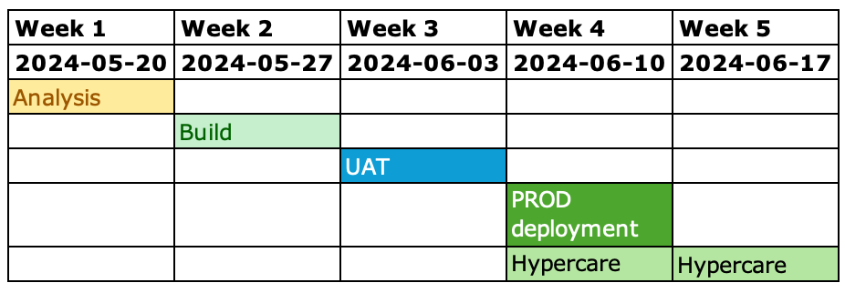
The total duration of the project is therefore expected to be 3 weeks as well as an additional 2 weeks of hypercare support.
The total cost is therefore estimated to be between £7 800 and £9 540.
These costs and timelines are forecasts. Any expected variations will be communicated via the weekly project status reports provided by Open Box.
All amounts are quoted in GBP and exclude VAT, if applicable.
The project cost will be billed monthly, in arrears, up until the completion of the final project phase. Cost will be reported to Grainger on a in the weekly project management report during the course of the project. The cost will not exceed the upper limit of £9 540 without prior consultation.
This quotation is valid for 30 days and is assumed to start on 20th May 2024 or during the following 1-2 weeks, contingent on operational factors.

Acceptance
The parties hereto, each acting under due and proper authority, have executed this Agreement as of the day, month and year first written below.

For and on behalf of Open Box Software For and on behalf of Grainger plc

Signature: _____________________ Signature: _____________________
Name: Sam Duncan Name:
Position: Salesforce Director Position:
Date: _____________________ Date: _____________________

